*ecse 211 design project*

Testing Document

Version *1.02*

*13/03/2018*

*ECSE 211 TEAM 11*

VERSION HISTORY

|  |  |  |  |  |
| --- | --- | --- | --- | --- |
| **Title** | Testing Document | | | |
| **Description** | Test the built system if meets all the requirements | | | |
| **Created By** | Tianyi Zou, Testing leader | | | |
| **Date Created** | 1st March 2018 | | | |
| **Version Number** | **Modified By** | **Modifications Made** | **Date Modified** | **Status** |
| 1.00 | Tianyi Zou | Created the Testing Document Template | 1st March | Preliminary version of the document;  added testing template in the appendix |
| 1.01 | Luka Jurisic | Peer reviewed the document. Fixed some small errors and formatted the document. Added the introduction, 2 appendixes, and the test plan document. Created section 1.1-1.3.2 and section 2 | 2nd March | Preliminary template complete |
| 1.02 | Tianyi Zou, Enan Zaman | Completed section 3.2 and 3.4:Light sensor test and Wheels preference test | 13th March | All other tests remain |

TABLE OF CONTENTS

# 1 INTRODUCTION

1.1 Purpose of the Test Plan Document

1.2 Testing Tools

1.3 Quality Objective

1.3.1 Primary Objective

1.3.2 Secondary Objective

# 2 TEST DELIVARABLES

# 3 Hardware Testing

3.1 Ultrasonic Sensor

3.2 Light Sensor

3.3 Tracks

3.4 Wheels

3.5 Robot Structure

# 4 Software TESTING

4.1 Localization

4.2 Navigation

4.3 Obstacle Traversal

4.4 Search area

4.5 Capture

4.6 Obstacle avoidance

4.7 Wi-fi Integration

# 5 Integration testing

# 6 Test report templates

# 7 Test Reports

# 8 UPDATES AND DECISIONS

# Introduction

## 1.1 Purpose of The Test Plan Document

The Test Plan document documents and tracks the necessary information required to effectively define the approach to be used in the testing of the project’s product. The Test Plan document is created during the Planning Phase of the project. Its intended audience is the project manager, project team, and testing team. Some portions of this document may on occasion be shared with the client/user.

**1.2 TESTING TOOLS**

The following tools will be used for testing:

|  |  |
| --- | --- |
| PROCESS | TOOLS |
| Test Case Creation | Microsoft Word |
| Test Case Tracking | Microsoft Excel |
| Test Case Execution | Manual |
| Test Case Management | Microsoft Excel |
| Defect Management | Microsoft Excel |

# 1.3 Quality objective

# 

# 1.3.1 Primary Objective

The primary objective of this testing phase is to assure that the system meets the full requirements, including quality requirements, and maintain the metrics for each quality reequipments of the final design. At the end of the project development, the user should find that the project has met or exceeded all of their specifications detailed in the requirements.

# 1.3.2 secondary Objective

The secondary objective of this testing phase is to identify issues and propose solutions to all hardware and/or software issues, and to communicate all this to the project team. This requires careful and methodical testing of the design to ensure all areas of the system are scrutinized appropriately.

# TEST DELIVARABLES

The testing phase will allow a general progression of the project in terms of both hardware and software. The testing phase will provide key deliverables that fall into 3 basic categories: Documents, Test Cases and Reports. The figure below illustrates the dependencies of these 3 categories.

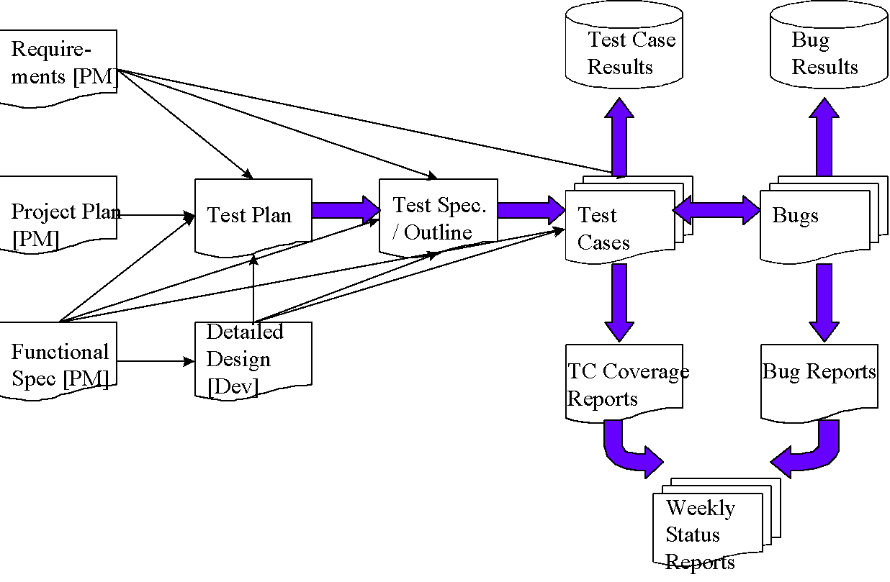

*Diagram Source: https://strongqa.com/qa-portal/testing-docs-templates/test-report*

# Hardware Testing

# *3.1-3.3, 3.5 To be updated iteravely*

# 3.2 Light Sensor

**Tester’s names:** *Enan Zaman, Tianyi Zou* **Test Date:** *03/12/18* **Software Version:** No code is used in this test.

**Hardware Version:** This test does not need a robot built. Only the brick and sensors are used.

**Objective:**

Determine which light sensor performs best by testing the distance between sensor and object where the sensor is able to detect object.

**Procedure:**

1. Put a blue paper on the table. Use a ruler to measure the distance by putting a block adjacent to the ruler so that the ruler can be stabilized and placed perpendicular to the table surface.
2. Connect the Port 1 on the brick to the sensor via a cable.
3. Use the tools application on the EV3 brick. Select Tools>Test Sensors >Go> Port 1>EV3 Color >Color ID.
4. Place the light sensor next to the ruler and on the table surface. Make sure the direction of light should be to the blue paper on the table.
5. Move up the light sensor along the ruler slowly.
6. Record the distance (d1)between the light screen of light sensor and the table surface when the value of color ID shown on the screen of EV3 brick becomes 2.0.
7. Repeat step 5 and record the distance (d2) when the value of color ID becomes 7.0.
8. Repeat step 5 and record the distance (d3) when the value of color ID becomes -1.0.
9. Do the same procedure to test other two light sensors.

**Expected result:**

The value of d1 and d2 are respectively the closest and farthest distance that the light sensor is able to precisely detect an object, which means light sensor can both detect the object in front of it and identify the color of the object. Value of d3 is the farthest distance that the light sensor is able to detect an object, but not able to identify the color.

**Test reports:**

|  |  |  |  |
| --- | --- | --- | --- |
|  | d1(cm) | d2(cm) | d3(cm) |
| Light sensor 1 | 0.3 | 1.8 | 4.5 |
| Light sensor 2 | 0.6 | 1.0 | 3.5 |
| Light sensor 3 | 0.5 | 1.5 | 3.7 |

**Conclusion:**

Different light sensor performs differently. Generally all sensors can detect objects well within the distance between 0.6 cm and 1.0 cm. Sensors can still detect objects but fail to identify the color at distance from 1.8 cm to 3.5cm.

**Action:**

We have to place the sensor at distance between 0.6 cm and 1.0 cm from the block in order to detect the block and identify its color.

**Distribution:** Hardware team

# 3.4 Wheels

**Test’s Title: Wheel Preference Test**

**Tester’s names:** *Enan Zaman, Tianyi Zou* **Test Date:** *03/10/18* **Software Version:** *1.00*

**Hardware Version:** *1.01*

**Objective:**

The objective of this test was to check whether to use the treads or the regular wheels. Treads can be very useful at overcoming the bumps and not implementing a variable track. Fears include treads not being accurate during navigation. All these outcomes will be tested, and the best form of transportation will be implemented on the final robot.

**Background knowledge:**

*Test information*

* Test treads and regular wheels on both the bridge to check if they will overcome the bumps. Then check the navigation on both form of transportation to see if there is any discrepancy in accuracy.

**Goal:**

* To find out whether the treads or regular wheels will be implemented on the final robot.

**Procedure:**

1. Build a robot using the treads.
2. Use lab two code to see how accurate the treads conduct the square navigation. Check whether the robot can overcome the bumps on the bridge.
3. Build a robot using the regular wheels.
4. Use lab two code to see how accurate the robot performs the square navigation. Check whether the robot can overcome the bumps on the bridge.
5. Compare the treads and regular wheels.

**Expected Results:**

* It is expected both the regular wheels and treads will overcome the bumps on the bridge as they are not impossible to travel through. It is expected that the treads will be less accurate than the regular wheels during navigation. These little discrepancies can accumulate at the end of the day.

**Test Report:**

*Regular Wheels:*

The regular wheels had a lot of difficulties plowing through the bumps on the bridge due to the marble on the back end. Two marbles were later placed to help ease the robot, but it didn’t make a significant difference. When the marble at the back end was replaced with a wheel, the robot was able to make it through the bumps of the bridge with not much issue. The regular wheels on the other hand are more reliable for accuracy during the square navigation.

*Treads:*

Overcomes the bumps on the bridge with ease. There are accuracy issues when the robot is trying to complete the square navigation.

**Conclusion:**

Through the tests, it is noticed that the best form of transportation to implement on the robot are the regular wheels. Two wheels will be paired on each motor to help with traction. The back end of the robot will be sitting on a lazy regular wheel. Considering the regular wheels can overcome the bumps with no problem whatsoever, it isn’t worth ruining the accuracy of the navigation by implementing the treads on the robot.

**Action:**

*Regular Wheels:* Try and make modifications to the regular wheels in order to make the robot track steady and make the navigation as perfect as possible with the hardware.

**Distribution:** Hardware Team

# 5 Test report templates

# Testing template

**Test’s Title:____________________**

**Tester’s names:___________________________________ Test Date:________________________**

**___________________________________ Software Version:__________________**

**___________________________________ Hardware Version:_________________**

**___________________________________**

**Objective:**

**Background knowledge (if needed):**

**Procedure:**

**Expected Results:**

**Test Report:**

|  |  |  |  |  |  |  |
| --- | --- | --- | --- | --- | --- | --- |
| **Tests** | **Variables** | | | | **Passed?** | **Comments:** |
|  |  |  |  |  |
| **1** | v |  |  |  |  |  |
| **2** |  |  |  |  |  |  |
| **3** |  |  |  |  |  |  |
| **4** |  |  |  |  |  |  |
| **5** |  |  |  |  |  |  |
| **6** |  |  |  |  |  |  |

**Conclusion/Action/Distribution**

# Test Plan Approval

The undersigned acknowledge they have reviewed the **Test Plan** document and agree with the approach it presents. Any changes to this document will be coordinated with and approved by the undersigned.

|  |  |  |  |
| --- | --- | --- | --- |
| Signature: |  | Date: |  |
| Print Name: |  |  |  |
| Title: |  |  |  |
| Role: |  |  |  |

|  |  |  |  |
| --- | --- | --- | --- |
| Signature: |  | Date: |  |
| Print Name: |  |  |  |
| Title: |  |  |  |
| Role: |  |  |  |

|  |  |  |  |
| --- | --- | --- | --- |
| Signature: |  | Date: |  |
| Print Name: |  |  |  |
| Title: |  |  |  |
| Role: |  |  |  |

**Appendix A: References**

The following table summarizes the documents referenced in this document.

|  |  |  |
| --- | --- | --- |
| **Document Name and Version** | **Description** | **Location** |
|  |  |  |

**Appendix B: Key Terms**

The following table provides definitions for terms relevant to this document.

|  |  |
| --- | --- |
| **Term** | **Definition** |
|  |  |
|  |  |
|  |  |